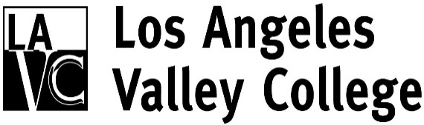
Citizens Building Oversight Committee
http://www.lavc.edu/revitalizingvalley/oversitecommittee.html

Committee Members
Mark an “x” next to each person who is present:

*Pat Ballew, LAVC Foundation, Chair
Kevin Ary, Member at Large
Eric Bubbers, LACCD Representative
Asta Criss, Valley Glen Neighborhood Association
Lisa Davis, Studio City Neighborhood Council
Carlos Ferreyra, Greater Valley Glen Council
Diedra Stark, Retirees Association of LAVC
Waltona Manion, Member at Large
Jo Ann Rivas, NOHO Neighborhood Council
Vacant, Sherman Oaks Neighborhood Council
Vacant, Valley Village Neighborhood Council
Student Member

Ex Officio
Dr. Erika Endrijonas, President

Resource Members
Mike Lee, VPAS
Mark Strauss, College Project Director
Armine Galukyan, Executive Assistant

*Chair

LAVC Mission Statement: Los Angeles Valley College serves as a leader in student success, with pathways for certificates, degrees, transfer, and continuing education. We enable students to advance their education, personal development, and quality of life, empowering them to be productive and engaged members of the global community.

Citizens Building Oversight Committee
5800 Fulton Avenue
Valley Glen, CA 91401

January 9, 2017 - 6:00 PM
ACA Building, Conference Room #2507
Agenda
- Welcome and Introductions
- Public Comments
- Approval of Minutes
- Chairperson’s Report- Pat Ballew
- Update on District Citizens’ Oversight Committee- Eric Bubbers
- Building Construction Update- Mark Strauss
- President’s Report
- Items from the Floor

