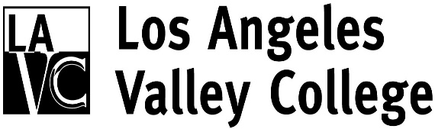
Citizens Building Oversight Committee
http://www.lavc.edu/revitalizingvalley/oversitecommittee.html

Committee Members
Mark an “x” next to each person who is present:

*Pat Ballew, LAVC Foundation, Chair

Kevin Ary, Member at Large

Eric Bubbers, LACCD Representative

Asta Criss, Valley Glen Neighborhood Association

Lisa Davis, Studio City Neighborhood Council

Carlos Ferreyra, Greater Valley Glen Council

Diedra Stark, Retirees Association of LAVC

Vacant, Neighborhood Council Valley Village

Vacant, Sherman Oaks Neighborhood Council

Student Member

Ex Officio
Dr. Erika Endrijonas, President

Resource Members

Mike Lee, VPAS

Armine Galukyan, Executive Assistant

Mark Strauss, College Project Director

*Chair

LAVC Mission Statement: Los Angeles Valley College serves as a leader in student success, with pathways for certificates, degrees, transfer, and continuing education. We enable students to advance their education, personal development, and quality of life, empowering them to be productive and engaged members of the global community.

Citizens Building Oversight Committee
5800 Fulton Avenue
Valley Glen, CA 91401

July 12, 2016 - 6:00 PM
President’s Conference Room (Admin 2)

Agenda

- Welcome and Introductions
- Approval of Minutes
- President’s Report – Mike Lee
- Update on District Citizens’ Oversight Committee- Eric Bubbers
- Building Construction Update- Mark Strauss
- Potential New Bond
- Items from the Floor

