- https://heartland.ecsi.net/index.main.html#/access/lookup
- Double click the right square “I need my 1098-T tuition tax statement”

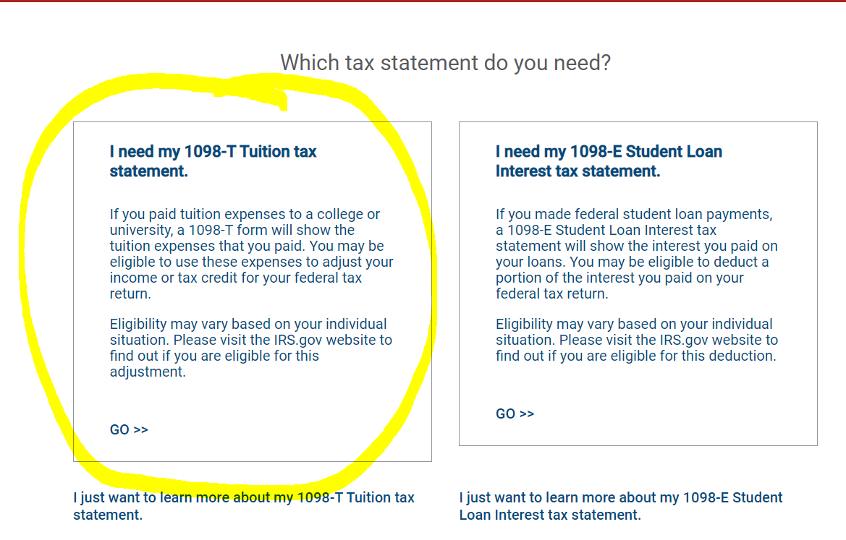
- Type “Los Angeles Community College District” and click “submit”
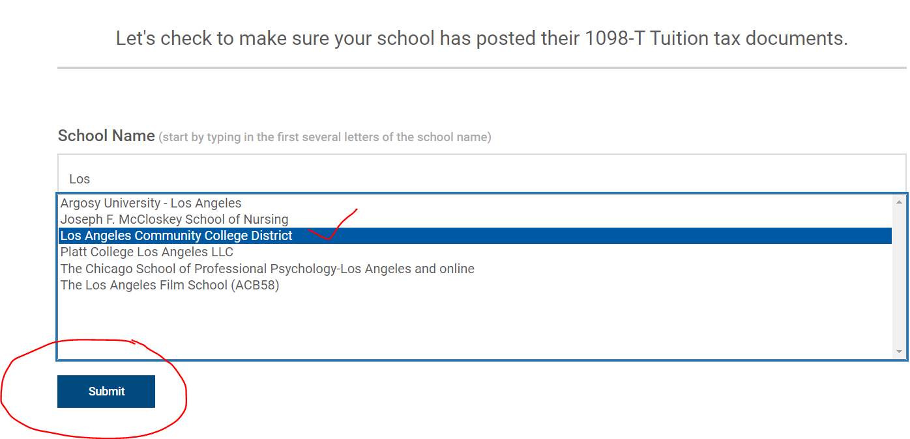
- Fill up your First Name, Last Name, SSN and your zip code in our system. Select “I am not a Robot”, then Click “continue”.
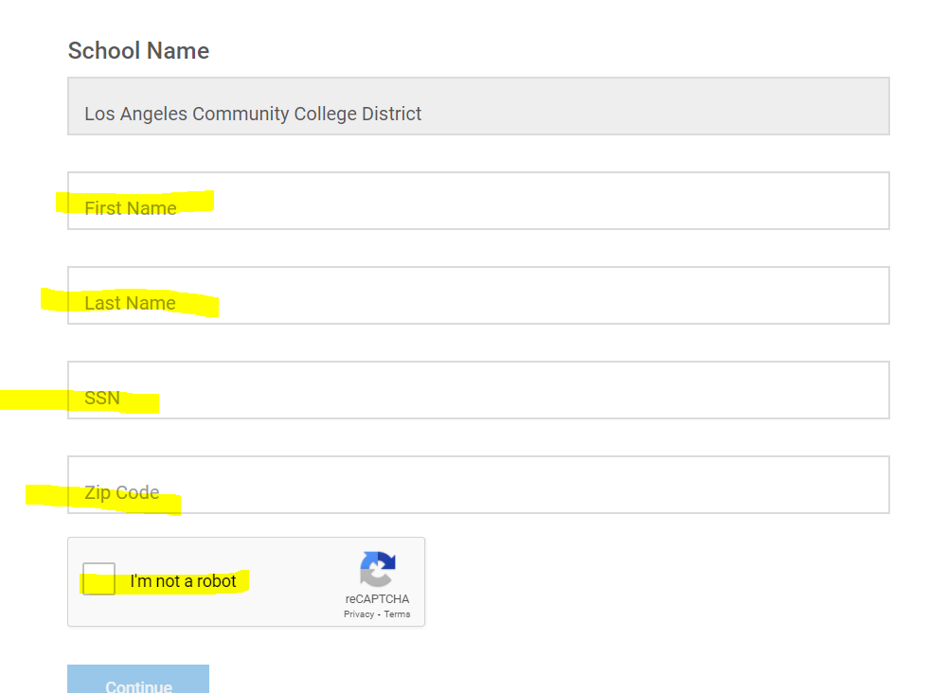

- Click view details

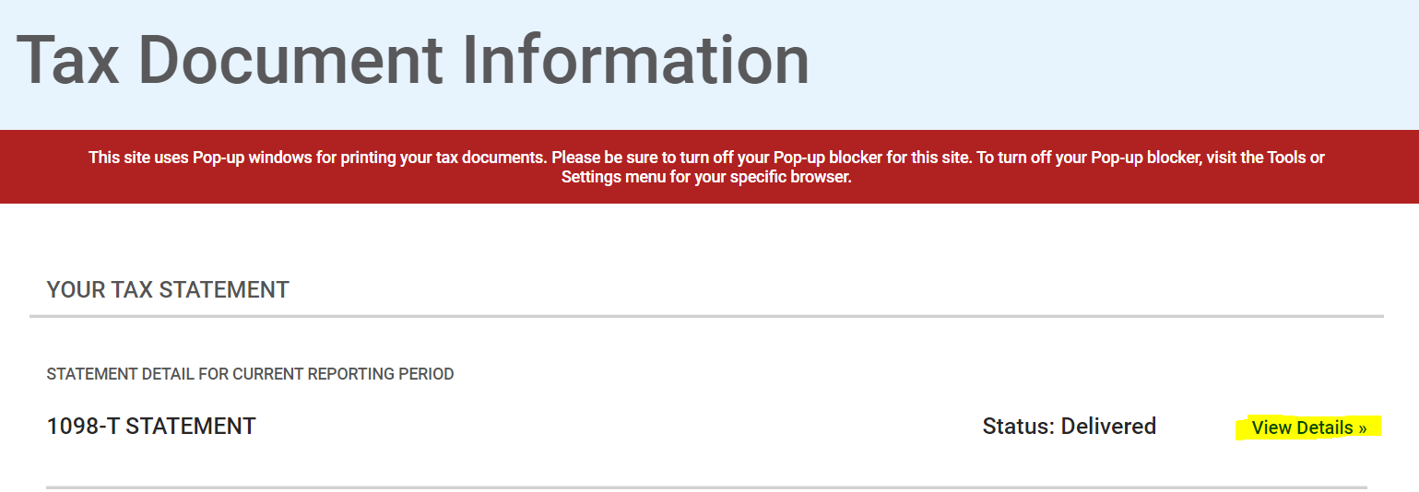
- Click “view and print statement” to download student forms.
